Lab: Shannon Diversity Index

**Purpose:**

* To employ the concept of the null hypothesis in a scientific experiment.
* To determine the Shannon Diversity Index for two groups of “species.”
* To compare and analyze the two samples using the Shannon method.

**Background:**

A central theme in ecology is **biodiversity,** which often serves as a measure of the overall health of an ecosystem. Declining biodiversity can indicate that the ecosystem is undergoing some type of environmental stress. Further study may then help to pinpoint that stress.

There are many methods that ecologists use to calculate species diversity. The Shannon Diversity Index is a common way of showing that diversity involves not only numbers of different species, but also how well each of these species is represented in different “habitats.” The Shannon value “H” can range from no diversity at 0.0 (think of a Christmas Tree farm) to a maximum diversity of 4.0 (think of a rainforest). These values have no real meaning by themselves, but can be used to compare two communities or the same community at different times. A large value of H indicates that if you randomly pick in your test area, the odds are the second individual will be different from the first. In this investigation your group will collect data from the vehicles in the student and faculty areas of parking at the school.

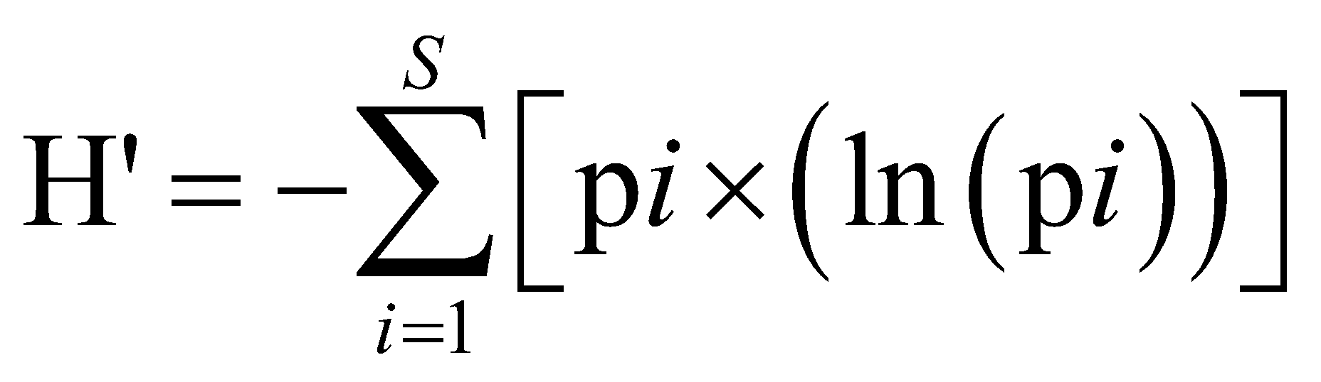

You need to begin with a good hypothesis. This statement needs to show cause and effect between two aspects of the situation being investigated. The standard hypothesis is an “if…then” statement that connects the two aspects being discussed. Experiments of this nature attempt to agree or disagree with the hypothesis. For this lab we will employ a second type of hypothesis, called the **null hypothesis.** This is a statement that there is **no relationship** between the two aspects of the situation under consideration. Experiments of this format are designed to disprove the null hypothesis. Theoretically in science it is easier to disprove something than it is to prove something. The null hypothesis is often the reverse of what the experimenter actually believes; it is put forward to allow the data to contradict it.

**Prelab:**

1. State your null hypothesis here

| There is no relationship between age (student vs. teacher) and diversity of type of car. |
| --- |

**Materials:**

* vehicles parked at the school/neighborhood
* calculator with natural log function

**Procedure:**

Your team of four people will be divided into two people who will count the vehicles in the faculty area of parking and two who will count the vehicles in the student area of parking. Mr Jones will explain where these areas are located. Fill in one chart completely for each site.

**Results:** see data tables. Fill them in using the calculations below:

**Calculations:**

The Shannon equation is:

H’ = - sum(pilnpi)

Where: H’ = Shannon Diversity Index

pi = the ratio of the number of organisms of a species to the total number of organisms

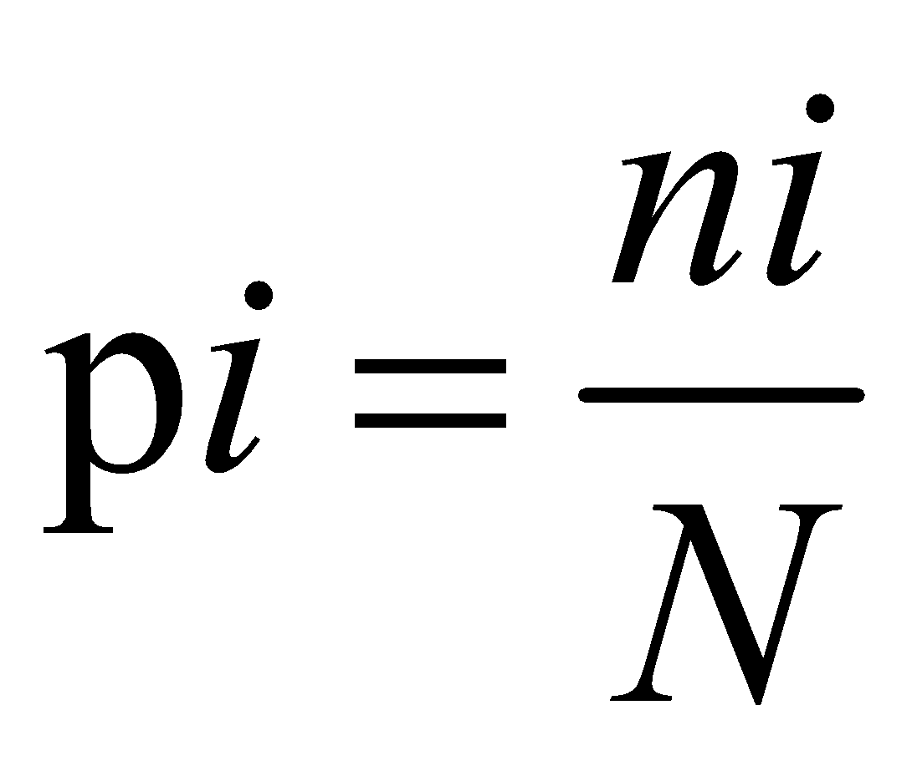 where: *ni*= number of individuals in species “i”

*N*= total number of individuals of all species

lnpi = the natural log of pi

\*\**Note there is a negative sign before the sum sign, which means that your answers will always be positive.*

**Example Data Set**

Parking Lot A:

| Species of Car | Species Identifier Code | Number of Individuals in Parking Lot A |  |  |  |
| --- | --- | --- | --- | --- | --- |
| I | ni | pi | ln(pi) | pi (ln(pi)) |
| Sedan (4-door or 2-door with regular trunk) | 1 | 10 | 0.17 | -1.79 | -0.30 |
| SUV (higher off ground, gate in back) | 2 | 10 | 0.17 | -1.79 | -0.30 |
| Van or Mini-Van (sliding doors with hatch in back) | 3 | 10 | 0.17 | -1.79 | -0.30 |
| Pick-Up Truck (cargo in back) | 4 | 10 | 0.17 | -1.79 | -0.30 |
| Station Wagon or Hatchback | 5 | 10 | 0.17 | -1.79 | -0.30 |
| Bikes or Motorcycles | 6 | 10 | 0.17 | -1.79 | -0.30 |
| **TOTAL** | S=6 | N=60 |  |  | -1.79 |

**Therefore H’=1.79**

Parking Lot B:

| Species of Car | Species Identifier Code | Number of Individuals in Parking Lot A |  |  |  |
| --- | --- | --- | --- | --- | --- |
| I | ni | pi | ln(pi) | pi (ln(pi)) |
| Sedan (4-door or 2-door with regular trunk) | 1 | 1 | 0.02 | -4.09 | -0.07 |
| SUV (higher off ground, gate in back) | 2 | 2 | 0.03 | -3.40 | -0.11 |
| Van or Mini-Van (sliding doors with hatch in back) | 3 | 25 | 0.42 | -0.88 | -0.36 |
| Pick-Up Truck (cargo in back) | 4 | 32 | 0.53 | -0.63 | -0.34 |
| Station Wagon or Hatchback | 5 | 0 | n/a | n/a | n/a |
| Bikes or Motorcycles | 6 | 0 | n/a | n/a | n/a |
| **TOTAL** | S=4 | 60 |  |  | -0.88 |

**Therefore H’= 0.88**

**Which parking lot above is more diverse?** Lot A (S=6, H’=1.8). The car species are equally represented in this lot. We say that this parking lot (community) has a high degree of evenness. Lot B is less diverse based on our indexes (S=4, H’=0.88) and has low evenness, because the car species are unequally represented. Pick-up trucks are the most common species in Lot B, followed by Vans. This lot has a high degree of dominance by these two species (p3+p4=.95=95% of the individuals in this parking lot are Trucks and Vans).

| **Diversity Measurement** | **Community A (Lot A)** | **Community B (Lot B)** |
| --- | --- | --- |
| Species richness (S) | 6 species | 4 species |
| Evenness | High | Low |
| Shannon Diversity Index (H’) | 1.79 | 0.88 |
| Overall Diversity | High | Low |

Now collect data

**Student Parking Lot/Neighborhood Street(Lot/Community A)**

| Species of Car | Species Identifier Code | Number of Individuals in Parking Lot A |  |  |  |
| --- | --- | --- | --- | --- | --- |
| I | ni | pi | ln(pi) | pi (ln(pi)) |
| Sedan (4-door or 2-door with regular trunk) | 1 | 22 | 0.12 | -2.10 | -0.25 |
| SUV (higher off ground, gate in back) | 2 | 12 | 0.07 | -2.70 | –0.19 |
| Van or Mini-Van (sliding doors with hatch in back) | 3 | 8 | 0.05 | -3.10 | -0.16 |
| Pick-Up Truck (cargo in back) | 4 | 6 | 0.03 | -3.38 | -0.10 |
| Station Wagon or Hatchback | 5 | 14 | 0.08 | -2.55 | -0.20 |
| Bikes or Motorcycles | 6 | 117 | 0.65 | -0.04 | -0.03 |
| **TOTAL** | | 179 | 1 |  | -0.93 |

**H’ = -0.93**

**Faculty Parking Lot/Neighborhood Street (Lot/Community B)**

| Species of Car | Species Identifier Code | Number of Individuals in Parking Lot B |  |  |  |
| --- | --- | --- | --- | --- | --- |
| I | ni | pi | ln(pi) | pi (ln(pi)) |
| Sedan (4-door or 2-door with regular trunk) | 1 | 38 | 0.40 | -0.91 | -0.37 |
| SUV (higher off ground, gate in back) | 2 | 37 | 0.39 | -0.93 | -0.37 |
| Van or Mini-Van (sliding doors with hatch in back) | 3 | 1 | 0.01 | -4.54 | -0.05 |
| Pick-Up Truck (cargo in back) | 4 | 5 | 0.05 | -2.93 | -0.16 |
| Station Wagon or Hatchback | 5 | 13 | 0.14 | -1.98 | -0.27 |
| Bikes or Motorcycles | 6 | 0 | 0 | N/A | N/A |
| **TOTAL** | | 94 | 1 |  | -1.21 |

**H’ = 1.21**

**Fill in the following chart and use for your analysis:**

| **Diversity Measurement** | **Community A (Lot A)** | **Community B (Lot B)** |
| --- | --- | --- |
| Species richness (S) *(#)* | 6 | 5 |
| Evenness *(high/low)* | higher | lower |
| Shannon Diversity Index (H’) | 0.93 | 1.21 |
| Overall Diversity *(high/low)* | lower | higher |

**Analysis:** Remember to **provide data** to support your answer.

1. Compare the data related to the two communities. Evaluate this in light of your null hypothesis.

| The cars in the teacher parking lots are more diverse than the cars in the student parking lot. You can tell because the Shannon Diversity Index (H’) of the teacher cars is 0.93, and H’ for the student parking lot is 1.21, which is higher. Since the diversity is different, there is a relationship between age and car type diversity, so we reject H0. |
| --- |

1. Which species are more dominant in each community? Why do you think this is the case?

| Among the teacher cars, Sedans and SUVs are the most dominant (they have the highest pi = 0.40, 0.39). This may be because teachers often have families and need to drive cars that are practical and can fit multiple people. Among the student cars, bikes are the most dominant (highest pi = 0.65). This may be because many students do not have drivers’ licenses, so they bike instead. |
| --- |

1. Which group, if any, is more diverse? Why do you think this is the case?

| The teacher cars are more diverse. This may be because teachers are older and often have licenses, so they have a larger ability to choose what type of vehicle they drive and this leads to more diversity. On the other hand, many students are often limited to just bikes because they are younger and cannot get their licenses yet. |
| --- |

1. Would the Shannon Index be a good comparison for evaluating dinosaur and plant diversity in a fossil bed 150 million years old and one that is 90 million years old? Explain.

| Yes, the Shannon Index would be a good comparison. The Shannon Index is used to compare the diversity between 2 communities, and in this case, the communities would be the dinosaur and plant diversity for each of the two fossil beds. |
| --- |